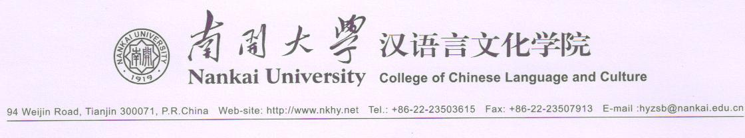
留 学 生 入 学 申 请 表
Application Form for International Students

照片

Photo

1. Name: Family Name（姓）：
Given Names（名）：
Chinese Name （中文名）：
2. Nationality（国籍）： 3. Sex（性别）：M/男 □ F/女□
4. Marital Status（婚否）： Single/未婚 □ Married/已婚 □
5. Passport No.（护照号码）： 6.Passport valid until(护照有效期)：
7. Date of Birth (出生日期)： Year/年 Month/月 Date/日
8. Place of Birth (出生地) ： 9. Religion(宗教信仰)
10. Your Mailing Address in Your Home Country (本国邮寄地址) ：

Tel. in Your Home Country (本国联系电话)：
E-mail(邮箱)：
Present Address in China(在华联系地址)：

Tel. in China (在华联系电话)：
11. Education Level（最高学历）：
12. Plan of Study in Nankai University（来我校学习计划）：
A. Chinese Language Student（汉语语言进修生）：□
B. Bachelor’s Degree（本科生）： □ Major/专业：
C. Master’s Degree（硕士生）： □ Major/专业：
13. Duration of Study at Nankai University（在我校学习时间）：
Year/年 Month/月 to（至） Year/年 Month/月
14. Contact Person in China/Recommended by（在华联系人/推荐人）：
Name/姓名： Employer/单位：
Tel./电话： Fax/传真：

Applicant’s Signature(申请人)： Date(日期)：
Application Procedure and Instructions（注意事项）：
The new academic year begins in September. Applicants are asked to send the completed Application Form before the end of June for the new academic year or before the end of December for the Spring semester that starts in February of the following year.
南开大学新学年为9月入学。申请人应于6月底前，将申请材料寄来；申请春季（2月份）入学的应于前一年的12月底前将材料寄来。

- Applicants must submit to Nankai University along with the completed Application Form, 8 copies of photos (2 inch), a copy of their education diploma and/or certificates. Letter of Recommendation is needed if you are an exchange student on an exchange program.
将填写好的申请表，8张照片（2寸）和学历证书的复印件寄到南开大学。校际交流的学生需提供推荐信。
- After receiving the application materials by the date specified above, we will send the applicant the Visa Application Form (JW202) and the Letter of Admission.
我校在收到按上述指定日期寄出的申请材料后，将向申请人寄发来华签证申请表（JW202表）和入学通知书。
- With the Visa Application Form (JW202) and the Letter of Admission along with the completed Physical Examination Report (if the duration of study is more than 6 months), the applicant should apply to the Chinese Embassy (or Consulate) for the X visa (student’s visa), or for the F visa if the duration of study is less than 6 months.
申请人可持JW202表、入学通知书和《外国人体格检查记录》（学习期限超过6个月的学生）到中国驻贵国使（领）馆办理来华学习签证（X签证），学习期在6个月以内的可申请F签证。
- The student is required to register at Nankai University during the time specified in the Letter of Admission and go through the formalities for applying for residence card within 30 days after arriving in China. The student shall be fined by the local Public Security Bureau if s/he fails to do so within the said period.
学生应按入学通知书规定的时间来校报到。入境后30天之内应申办外国人居留证，否则将受到公安部门的处罚。

